9/5/2023

Rupom Saha c3268577

The University of Newcastle

Final Year Project

Draft

# Executive Summary

The use of modern Communication devices is integral to our lives. We have more technological devices in our time than the number of humans on earth. These devices are bound to get into a lot of accidental malfunctions. Electronics Repair is a very complex, time consuming and money consuming process. The process also requires special knowledge and experience to execute.

Finding ways to preserve communication is very essential to our modern way of life. Repairing and recycling is crucial in the preservation of that modern means of interaction. In a world with rising numbers of AI and automated technology, it is time for our devices to be fixed automatically.

There are multiple mobile phone companies across the whole world. They all have their own blueprints for their products. Some require original parts for replacement, and some can be done with aftermarket products. Decisions of these repairs are challenging for the common person. As the new age of automation arises, we are bound to meet a turning point where phone repair and solutions are easier to automize than the touch of human error.

Table of Contents

Executive Summary 1

1. Introduction 3

2. Literature Review 4

2.1 Existing Literature 4

2.1.1 Thermal Imagining for PCBs 4

2.1.2 Automatic Diagnostics Device for Cars 4

2.1.3 The Importance of Repair and Recycle 4

2.2 Critical Evaluation 5

2.3 Gap Identification 6

2.4 Study Justification 7

3. Methodology 9

3.1 Design 9

3.1.1Fault Detection using Thermal Imaging 9

3.1.2 Automating Fault Detection Decision Making with State Machines 11

3.1.3 MATLAB Machine Learning toolbox for Fault Detection on Images 11

3.2 Data Collection 12

3.3 Data Analysis 13

3.4 Limitations 14

4. Problem Statement 15

4.1 Knowledge Gap 15

5. Discussion 16

6. Recommendation 17

6.1 Further Investigation 17

6.2 method Improvement Suggestion 18

6.3 Longitudinal Studies 19

6.4 Practical Implications 20

6.5 Future Research Path Recommendations 21

7. Conclusion 22

8. References 23

9. Bibliography 24

10. Appendix 28

# Introduction

There are several challenges with the phone repairing process that needs to be addressed. In this project we will deal with the process of electronics repair and come to a modern innovative solution that involves automation. This project’s primary goal is to produce a system that can identify hardware faults, analyse, and rectify. There are also software faults that the report will suggest, but will be delegated for future research.

The primary approach includes isolating a thought pattern of identifying damaged and unresponsive parts that will highlight the underlying problems with the device. There must be a prototype that can utilise the machine learning to produce a series of menial tasks that will save time in the long run. The program would suggest different solutions to all kinds of problems, starting from repair to the mother board to recycling and selling of parts. The program and device can search the internet with possible solution to repairs and damage.

The required diagnostics will involve all with the help of repair knowledge integrated with machine learning which can solve most repair problems. For repairs on complicated circuits like motherboard and PCBs it will require thermal imaging to seek damages precisely.

This paper will discuss all possible problems faced by smartphone customers that cannot be solved with a basic smartphone knowledge. Recycling and restoring damaged smartphones in a circular economy would benefit us in the future.

This topic is only the beginning of this discussion, as we discuss future possibilities of expanding these findings.

# Literature Review

## Existing Literature

### Thermal Imagining for PCBs

A phone’s motherboard is essentially a PCB, so a whenever a part of the PCB gives out or is not working, thermal cameras are used on a detect that problem. Engineers have figured to use thermal cameras to detect parts on a PCB that is overheating or not passing any current at all. “An Efficient Fault Detection Method for Induction Motors using Thermal Imaging and Machine Vision” ([Javed et al, 2022](https://www.proquest.com/docview/2700773020?parentSessionId=dnZfsi%2BI4aHhbaJYVM2rC9gYV%2BvVdlT7C0YxtiQGVyU%3D&pq-origsite=primo&accountid=10499&sourcetype=Scholarly%20Journals)) states the use of image thermography to look at induction motors while running. The thermal camera points out different parts of the induction motor and monitors any unusual temperature changes.

### Automatic Diagnostics Device for Cars

An automotive is fitted with multiple sensors everywhere on its body, such as odometer, fuel gauge, engine sensors that monitor parameters like temperature and pressures of the engine, anti-lock braking system, etc. A device like OBD2 scanner is connect to a car by the port to test all the car sensors and run diagnostics ([Rimpas et al, 2019](https://www.sciencedirect.com/science/article/pii/S2352484719308649)).

### The Importance of Repair and Recycle

As we get closer to global warming’s tipping point, we are more concerned about limiting our carbon footprint. Every single new production of increases our carbon footprint little by little that the time for this climate change disaster is irreversible.

Mobile phone parts contain numerous number of metals, some of these metals like cadmium, lead, chromium, mercury, etc are toxic ([Prabhu N et al, 2022](https://www.ncbi.nlm.nih.gov/pmc/articles/PMC9925901/#:~:text=Metals%20like%20cadmium%2C%20lead%2C%20chromium,et%20al.%2C%202020).)). Research suggests that e-waste is one of the fastest growing waste stream in the world ([Dhir et al, 2020](https://www.sciencedirect.com/science/article/pii/S0959652620343146)). To preserve our planet for future generations it is high time for us to address these issues.

### Electronics Repair using Artificial Intelligence

### PCB Fault detection using thermal imaging and machine learning

### Predictive Maintenance using Machine Learning

### Identification of mobile phones using built in magnetometer

### 2.1.8

## Critical Evaluation

## Gap Identification

## Study Justification

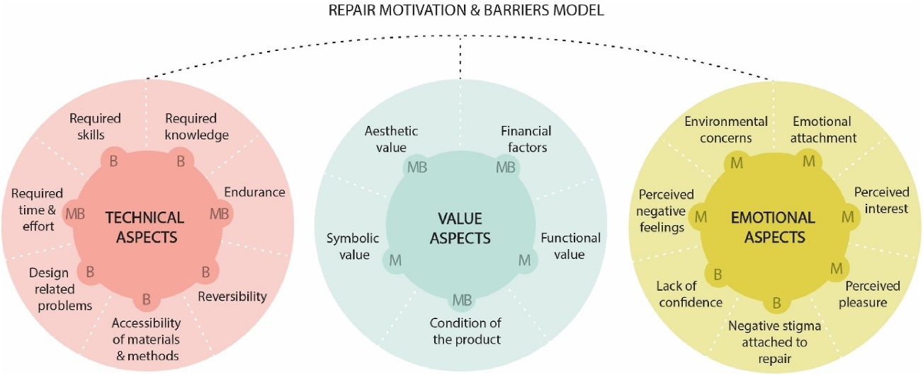

Figure 1: <https://ars-els-cdn-com.ezproxy.newcastle.edu.au/content/image/1-s2.0-S0959652620356900-gr8_lrg.jpg>

By identifying users’ motivations and the barriers related to product repair, this research aimed to understand user perspectives to increase product [circularity](https://www-sciencedirect-com.ezproxy.newcastle.edu.au/topics/engineering/circularity).

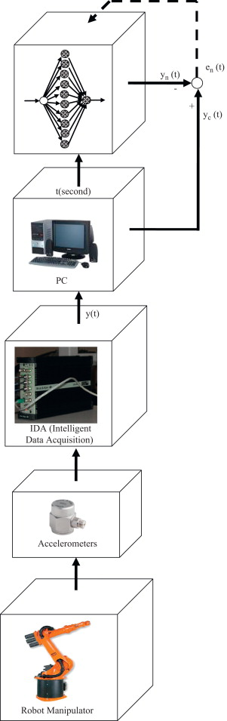

Figure 2: <https://www-sciencedirect-com.ezproxy.newcastle.edu.au/science/article/pii/S0736584510000682?via%3Dihub>

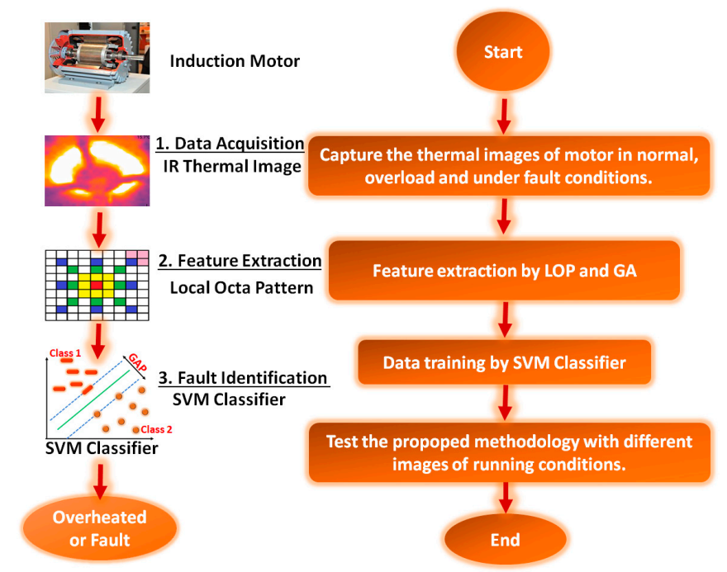

Figure 3: An Efficient Fault Detection Method for Induction Motors

The use of thermal imagining can be used to find small parts in PCBs that are not operational and should be replaced.

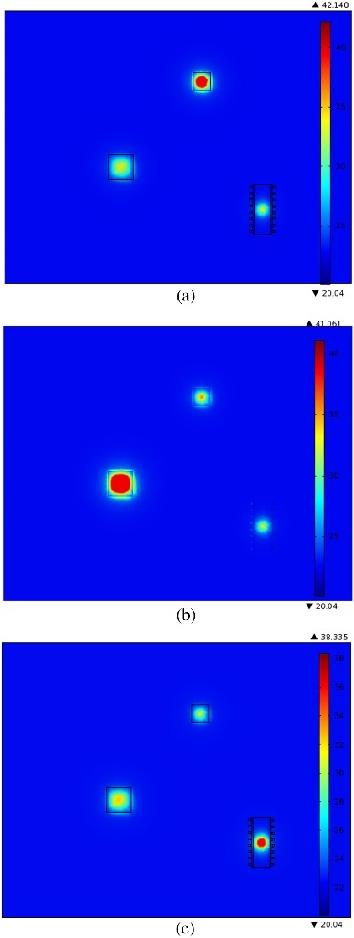

Figure 4: <https://www-sciencedirect-com.ezproxy.newcastle.edu.au/science/article/pii/S0026271417300367?via%3Dihub>

# Methodology

## Design

### 3.1.1Fault Detection using Thermal Imaging

Figure 5: <https://www-sciencedirect-com.ezproxy.newcastle.edu.au/science/article/pii/S0026271417300367?via%3Dihub>

Repair process algorithm using thermal imagining.

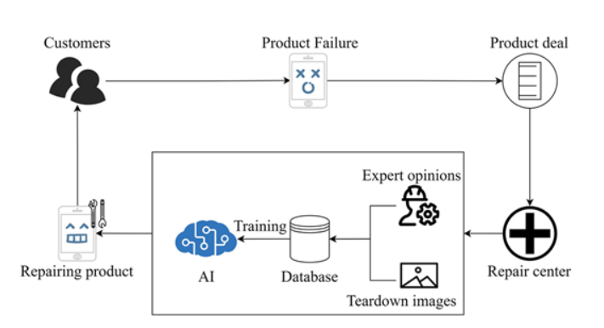

Figure 6: https://asmedigitalcollection-asme-org.ezproxy.newcastle.edu.au/manufacturingscience/article/146/2/020901/1167723/Automated-Evaluation-and-Rating-of-Product

The AI driven process to evaluate product repairability.

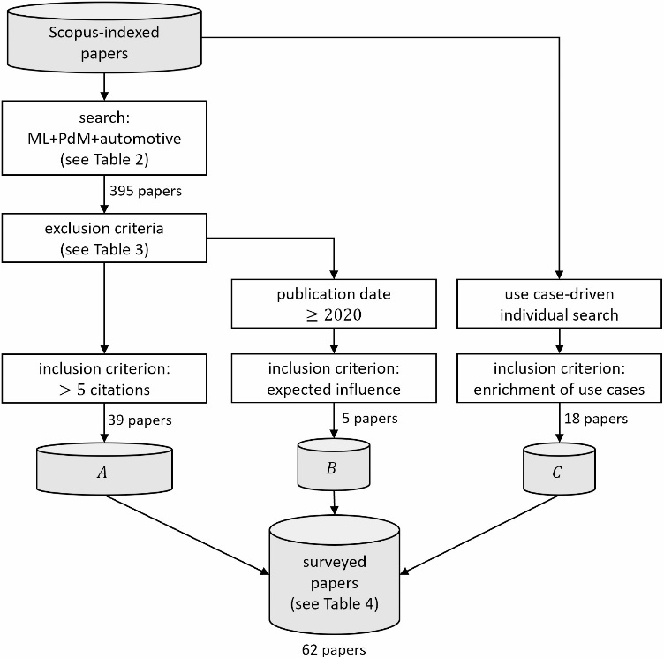

Figure 7: Predictive maintenance enabled by machine learning: Use cases and challenges in the automotive industry.

Use of this process is to get correct surveyed data from sources.

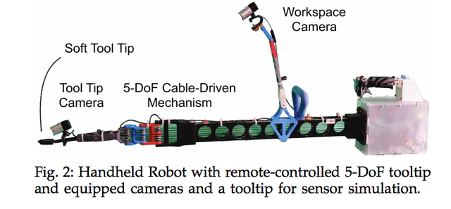

### 3.1.2 Camera for Workspace Observation

### 3.1.3 Automated Drill with Interchangeable Tips

### 3.1.4 Phone holder with 6 Degrees of Freedom

### 3.1.5 MATLAB Machine Learning toolbox for Fault Detection on Images

### 3.1.6 Automating Fault Detection Decision Making with State Machines

## Data Collection

## Data Analysis

## Limitations

# Problem Statement

# Knowledge Gap

# Discussion

| **Research through design repair methods** | |
| --- | --- |
| **1** | 3D printing product parts |
| **2** | 3D printed patches |
| **3** | 3D printing pen |
| **4** | kintsugi (Traditional Japanese repair method employed to mend broken ceramics with gold and silver.) |
| **5** | kintsugi for textiles |
| **6** | Kintsugi-Sugru |
| **7** | darning |
| **8** | Darning-Sugru |
| **9** | Boro (A special way of repairing Japanese traditional clothes) |
| **10** | patching |
| **11** | Sugru patching |
| **12** | basket weaving |

# Recommendation

## Further Investigation

## method Improvement Suggestion

## Longitudinal Studies

## Practical Implications

## Future Research Path Recommendations

1. privacy matters with broken phones.
2. AI powered Phone Repair.
3. Phone Data extraction with biometrics security access.
4. Phone Factory Reset Software/App for forgotten password.

# Conclusion

There are multiple organisations and departments working on this topic of automated repair using machine learning.

In part B we will set up a simulation of a device that can do automated repair on selective device.

# References

# Bibliography

Repair motivation and barriers model: Investigating user perspectives related to product repair towards a circular economy.

<https://www.sciencedirect.com/science/article/pii/S0959652620356900>

Repair of electronic products: Consumer practices and institutional initiatives.

<https://www.sciencedirect.com/science/article/abs/pii/S235255092100378X>

Mining consumer experiences of repairing electronics: Product design insights and business lessons learned.

<https://www.sciencedirect.com/science/article/abs/pii/S095965261631040X>

Selling 'Used' Cell Phones

<https://www.bankmycell.com/sell-broken-phones#:~:text=If%20your%20device%20has%20got,of%20the%20brand%20new%20value>

Fault Diagnosis of electronic system using artificial intelligence

<https://ieeexplore.ieee.org/abstract/document/1028367>

A More-than-Human Right-to-Repair

<https://dl.designresearchsociety.org/drs-conference-papers/drs2022/researchpapers/269/>

fault detection on robot manipulators using artificial neural network.

<https://www.sciencedirect.com/science/article/abs/pii/S0736584510000682>

An Efficient Fault Detection Method for Induction Motors Using Thermal Imaging and Machine Vision

<https://www.proquest.com/docview/2700773020?parentSessionId=dnZfsi%2BI4aHhbaJYVM2rC9gYV%2BvVdlT7C0YxtiQGVyU%3D&pq-origsite=primo&accountid=10499&sourcetype=Scholarly%20Journals>

Detection of Faulty Integrated Circuits in PCB with Thermal Image Processing

<https://ieeexplore.ieee.org/abstract/document/8946061>

Automated Evaluation and Rating of Product Repairability using Artificial Intelligence-Based Approach

<https://asmedigitalcollection-asme-org.ezproxy.newcastle.edu.au/manufacturingscience/article/doi/10.1115/1.4063561/1167723/AUTOMATED-EVALUATION-AND-RATING-OF-PRODUCT>

Model-Based Fault Detection in Electric Drivers Using Machine Learning

<https://ieeexplore-ieee-org.ezproxy.newcastle.edu.au/stamp/stamp.jsp?tp=&arnumber=1642691>

PCB-Fire: Automated Classification and Fault Detection in PCB

<https://arxiv.org/ftp/arxiv/papers/2102/2102.10777.pdf>

Learning, innovation, and sustainability among mobile phone repairers in Dhaka, Bangladesh

<https://dl.acm.org/doi/abs/10.1145/2598510.2598576>

Predictive maintenance enabled by machine learning: Use cases and challenges in the automotive industry.

<https://www.sciencedirect.com/science/article/pii/S0951832021003835>

Values in Repair

<https://dl.acm.org/doi/abs/10.1145/2858036.2858470>

Automated Detection of Printed Circuit Boards (PCB) Defects by Using Machine Learning in Electronics Manufacturing: Current Approaches

<https://iopscience.iop.org/article/10.1088/1757-899X/767/1/012064/meta>

PCB (Printed Circuit Boards) fault detection using machine learning.

<https://www.academia.edu/download/65761858/V10I2202110.pdf>

Innovations in Applied Artificial Intelligence

<https://link-springer-com.ezproxy.newcastle.edu.au/book/10.1007/b97304>

Human and Machine Communication Paradigm

<https://www-taylorfrancis-com.ezproxy.newcastle.edu.au/books/mono/10.1201/9781003392699/cyborg-kuldeep-singh-kaswan-jagjit-singh-dhatterwal-anupam-baliyan-shalli-rani>

iPhone: The missing manual

<https://newcastle.primo.exlibrisgroup.com/discovery/fulldisplay?docid=cdi_globaltitleindex_catalog_168269747&context=PC&vid=61UON_INST:61UON&lang=en&search_scope=CentralIndex&adaptor=Primo%20Central&tab=CentralIndex&query=any,contains,mobile%20phone%20parts%20replacement%20with%20machine%20learning&offset=0>

Hybrid machine learning algorithms for fault detection in android smartphones

<https://onlinelibrary-wiley-com.ezproxy.newcastle.edu.au/doi/full/10.1002/ett.3272>

Remote repair, diagnostics and maintenance

<https://dl-acm-org.ezproxy.newcastle.edu.au/doi/abs/10.1145/1029496.1029501>

The right-to-repair movement: Sustainability and consumer rights

<https://journals-sagepub-com.ezproxy.newcastle.edu.au/doi/full/10.1177/20438869231178037>

This Robotic arm can lend a helping hand with repairs.

<https://www.popularmechanics.com/technology/robots/a29712497/robot-repair-arm/>

Premium Mechanical Arm Claw with Servo for Robot Hand, Black Metal Robot Gripper Kit, RC Fingers Paw DIY Robotic Part Manipulator Clamp for Arduino, School Science Project, Experiment, STEAM

<https://www.amazon.com/Premium-Mechanical-Gripper-Manipulator-Experiment/dp/B0BCYQQ4NG?th=1>

Phone Repair Common tools.

<https://blog.repairdesk.co/2021/08/23/repair-tools-for-your-cell-phone-repair-business/>

Identification of Mobile Phone using the Built-in Magnetometer Simulated by Motion Patterns

<https://www.mdpi.com/1424-8220/17/4/783#:~:text=A%20SVM%20learning%20algorithm%20is,like%20KNN%20and%20naive%20Bayes>.

OBD-II sensor diagnostics for monitoring vehicle operation and consumption.

<https://www.sciencedirect.com/science/article/pii/S2352484719308649>

Disposal of obsolete mobile phones: A review on replacement, disposal methods, in-use lifespan, reuse and recycling

<https://www.ncbi.nlm.nih.gov/pmc/articles/PMC9925901/#:~:text=Metals%20like%20cadmium%2C%20lead%2C%20chromium,et%20al.%2C%202020>).

Behavioral reasoning theory (BRT) perspectives on E-waste recycling and management

https://www.sciencedirect.com/science/article/pii/S0959652620343146

# Appendix